**Week 1 – LLO**

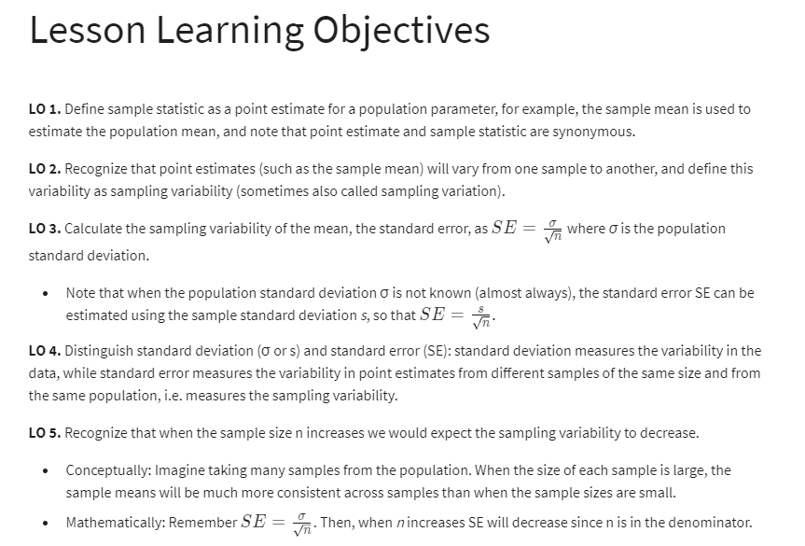

Example statement: 41% of the public believe that adults aged 18-34 are having the toughest time in today’s economy. 49% believe that they have taken a job they don’t want just to pay the bills. Margin of sampling error is 2.9% for results based on the total sample and 4.4% points for adults aged 18-34 at the 95% confidence level

* This means
* 41% +- 2.9%
* We are 95% confident that 38.1% to 43.9% of the public believe young adults, rather than middle aged or older adults, are having the toughest time in today’s economy
* And also
* 49% +- 4.4%
* We are 95% confident that 44.6% to 53.4% have taken a job they don’t want to pay the bills

**Sampling Variability & CLT**

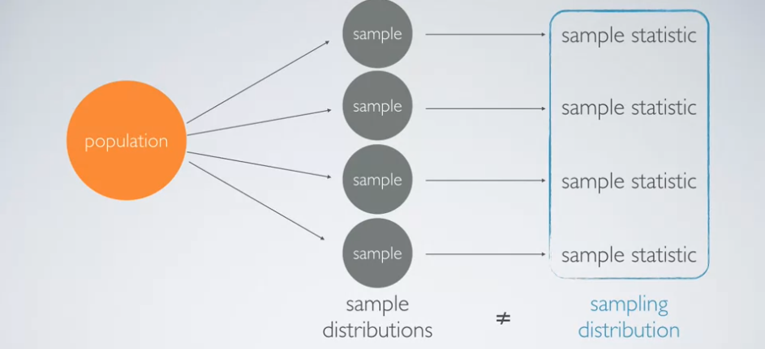

Example

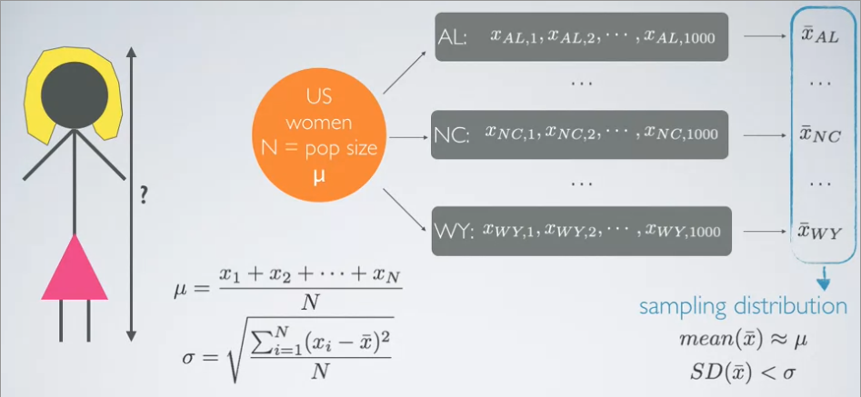

**Subtopic: CLT**

* As there are more observations in more samples, and the population distribution is normal, the sampling distribution will be closer and closer to a normal distribution
* Sampled observations must be independent with respect to the dependent variable

**Confidence Intervals LLOs**

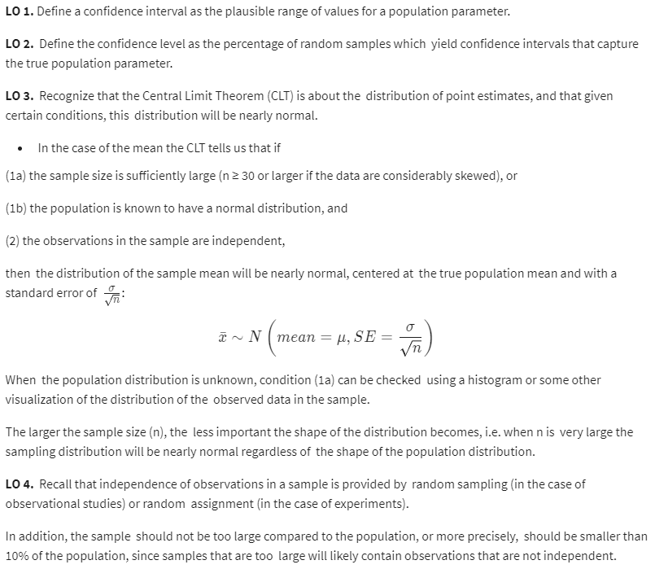

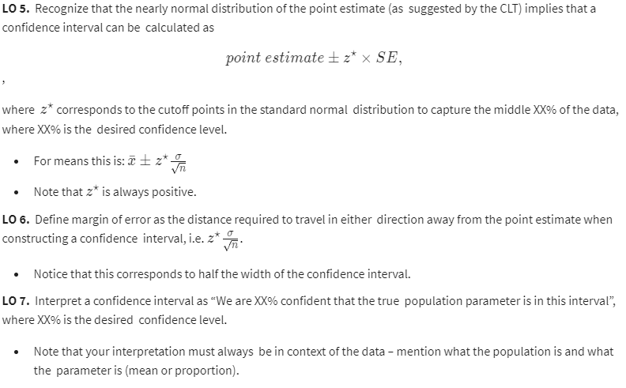

**Subtopic: Confidence Intervals**

Confidence Level:

* Suppose we took many samples and built a confidence interval from each sample using the equation
* Point Estimate +- 1.96*SE
* Then about 95% of those intervals would contain the true population mean (mu)
* We choose the confidence level, usually 90, 95, 98 or 99
* As the confidence interval increases, so does the width of the confidence interval, and the accuracy, but precision decreases
* To get higher precision and accuracy we can
  + Increase the sample size
* Remember that the confidence interval is about the overall population, not the sample
* For example:
  + It is correct to say
  + 95% of random samples of 1154 Americans will yield confidence intervals that contain the true average number of hours Americans spend relaxing after a work day

**Subtopic: Required Sample Size for Margin of Error**

* Margin of Error
  + Margin of error formula given confidence level, variability of the sample and sample size
  + To achieve the margin of error desired, just figure out the sample size by plugging into formula